The “Finals” Countdown
Thanksgiving break is over which means 1 thing… Finals are coming. 😱 But don’t panic! Here are some reminders and tips for finals season.
Tips for doing your best on finals:
- Get plenty of rest! Don’t pull all-nighters all week and get yourself too exhausted to think clearly! You’ll need your strength and energy to take these tests. Alternative to what you may think, missing sleep can hurt you more than those extra hours of “studying” help you. Without enough sleep, your memory and cognitive skills aren’t going to be up to par. You’d rather be well rested and have your full wits to think through questions on the final than spend hours exhausting yourself trying to force information into your memory.
- Eat good food! Get some healthy foods in your system. You’re not only feeding your body, but you’re feeding your brain! Coffee and Redbull might get your energy up to fight sleep deprivation, but it’s a temporary fix. You will crash and burn! Instead, fill up on some healthy foods, like fruits and veggies to help you have enough vitamins and energy to fuel some good studying.
- No cramming! You get information into your long-term memory over time. You may be able to scrape by with cramming (though many epically fail), but you will have a hard time in your classes next semester that builds on the knowledge you were supposed to get this semester. Study the whole semester through. If it's an online class, work on it little by little the whole semester, and don’t try to do it all during the last week of school (when you have all the other finals to worry about). It’s a marathon, not a sprint!
- Exercise. It’s a good way to relieve stress and stay healthy. Go outside and take a walk. Try out the gym your college offers its students. Play some intramural sports with other students. This is a great way to improve mental health and refresh your mind for another study block.
- Make a schedule, so you know what days your finals are, and when to study for each one. Also, mix your subjects. Study each class in small blocks instead of spending an entire day studying for 1 test. This technique helps improve overall retention of information and helps you study smarter not harder. It refreshes your brain to switch to something new and you won’t get trapped in boredom wasting perfectly good study time.
  - Bonus tip: check your finals schedule early. If you end up having all your finals on one day, you can talk to your professors EARLY and possibly reschedule your final for another day and time. The trick is, you have to do this early and with your professor’s permission.
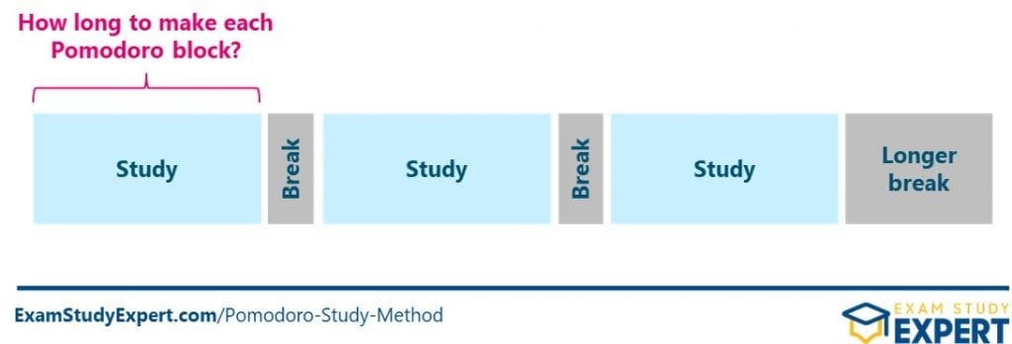
- Drink lots of water. Stay hydrated my friends. Your body will thank you.
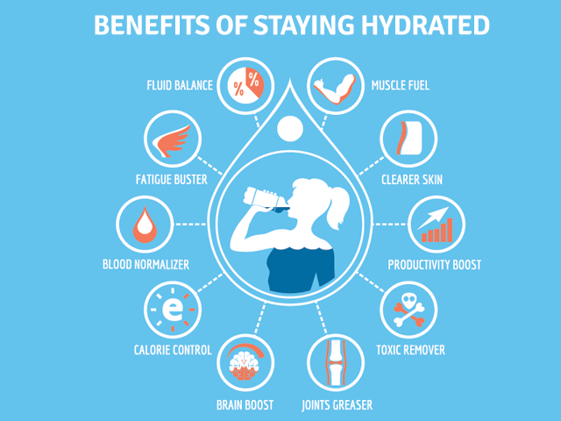
- Quiz yourself. Make your own study guides, flashcards, and practice test questions. This helps you see what you actually know, and what you need to spend time studying. Study with other students in your class! You can test each other and teach each other. Teaching someone else a concept is a great way for you to master the material. But most importantly, study in a way that you learn best. Some learn better in a quiet room by themselves, and others learn better in a cafe with some background noise. Find what works best for you and rock it out!
- Make time for something fun and enjoyable! Do something that makes you happy. It will increase your mood, boost your morale, lower your stress, and give your brain a break/endorphin boost.

Reminders for the end of the semester:
- Some college dorms have you check out and leave for winter break. You’ll need to give yourself time to pack, clean your room, and follow the checkout process for your dorm.
- If you rent books, calculators, or anything else for the semester, make sure to return them before the due date so you won’t have to pay late fees.
- Check your student account. You may have some fees, parking tickets, or deadlines you’ve forgotten about and need to take care of.
- Print out your schedule for next year. Many colleges have printing allowances that don’t carry over to the next semester. You already paid for the printing, so you might as well get your money’s worth and print what you’re going to need in the future.
- Speaking of getting your money’s worth, sometimes colleges give you a semester’s worth of Flex dollars or money you can use on campus at restaurants or campus shops. If you still have money on your card, either apply for a refund to get it back, or go ahead and spend up your last dollars so you won’t lose them (if they don’t roll over to next year).
- And don’t forget to enjoy your break! Take this time to rest and recharge for your next semester. You’ll need your strength and energy to hit the ground running next semester!

