Getting Along with College Roommates

It can be very hard to live with a roommate, especially if you’ve always had your own room growing up. Learning to share a space with anyone is tough, but more so if you’re navigating how to share with a stranger! Here are some suggestions and things to remember as you journey through living with a college roommate.
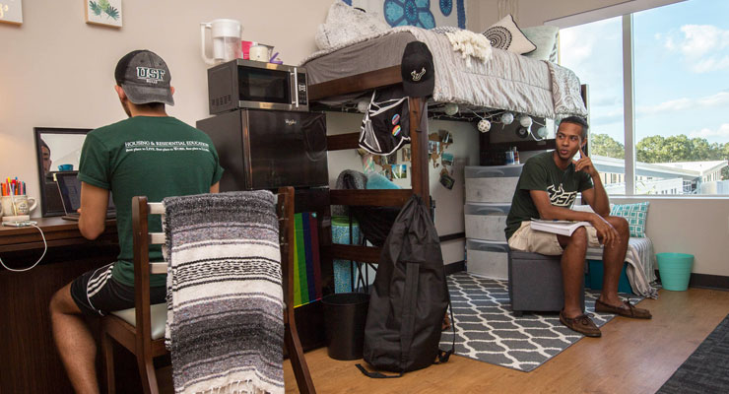
- Golden Rule: treat others how you want to be treated. If your roommate asks you to make reasonable sacrifices (ex: turn your music off, or listen to it quietly with headphones after 11 PM; throw your trash in the trashcan; don’t leave your clothes all over the room), respect their request and adjust accordingly. You’d like them to do the same for you if you had those issues.
- Make a roommate agreement setting the ground rules of what is and isn’t acceptable in the dorm, especially shared spaces. It doesn’t have to be too fancy or formal, but make sure you both know where you stand, and what’s expected of both of you. Some things to discuss and agree upon could be:
  - Cleanliness practices
  - Noise level (and/or quiet hours)
  - Boundaries (my space, your space, our shared space)
  - Inviting over guests
  - Who takes out the trash and when
  - Shower; sleep; study schedules
  - Music, TV, or game genres and content (it be nice to agree on them, or at least to take turns picking)
  - How to enforce following the rules; what to do when someone oversteps the boundaries or is disrespecting the agreement
- Respect each other’s space. Even if you live in a traditional-style dorm where you share 1 room, you need to have clear boundaries of space. Don’t clutter your stuff on their desk, furniture, or closets. And don’t go through their things unless they specifically gave you permission to borrow something. Privacy is limited when you have a roommate, so make sure to give each other what privacy you can. An additional tip is to give each other some time to be alone and have the room to yourself. This gives you both some needed space to decompress and can help you get along more smoothly when you are sharing the space again.
- Adjust to each other’s schedules. Maybe you’re an early bird, and your roommate is a night owl. Maybe one of you plays sports and has a regular practice schedule. Maybe you have a work schedule you have to include in your day. You’ll need to know when your roommate will be in the room and when they will be gone and plan accordingly. You’ll also want to be respectful and quiet during each other’s sleep times. If possible, you can go to a study room or the library if your roommate is sleeping during the time you were planning to get some homework done.
- Agree to Disagree. You don’t have to like all the same things or be best friends, but you do need to respect each other’s beliefs. Sometimes, arguing about something is not going to lead to a compromise somewhere in the middle. In those situations, it is best to stay on your side and respectfully disagree, rather than try to force someone to your side.

In the worst-case scenario of roommate problems, you may need to get your RA involved, or even apply to have a room change. However, you should try to resolve the issues on your own before choosing these options (most of the time, they’re going to ask how you’ve attempted to fix your differences on your own before they take action). Flexibility is KEY when trying to live with another person. You both will need to give a little and compromise in order to have a healthy relationship.

